Seabird Survey Report
22 May-6 June 2017
Integrated Statistics, Northeast Fisheries Science Center Contractor
16 Sumner St, Woods Hole, MA, 02543
Nicholas Metheny: procellateryx@gmail.com
Marine Species Observers: Nicholas Metheny and John Loch

Objective:
The primary goal of conducting seabird surveys aboard the Henry Bigelow in May/June 2019 was to gather data on the abundance and distribution of seabirds as a part of longer term monitoring efforts for these far-ranging apex predators. Our secondary objective in conducting theses surveys was to also collect data, when possible, on the abundance and distribution of other marine megafauna including, marine mammals, sea turtles, sharks, and other large pelagic fishes.
Collecting this data in conjunction with other biological data and abiotic factors will help better complete our “picture” of possible changes occurring in the marine ecosystem in the Northwest Atlantic from the Outer Banks to the Bay of Fundy.

Methods:
The protocol used for this survey is based on a standardized 300 meter strip transect survey, one that is used by various agencies in North America and Europe (e.g., Anon 2011, Ballance 2011; Tasker 2004).
The survey strip is 300 meters wide, with observers collecting data on all seabirds within that strip, from the bow to 90 degrees to either the port or the starboard side (depending on viewing conditions). Observations can be made in seas up to a Beaufort 7, in light rain, fog, and ship speeds between 8-12 knots (below 8 knots, the data becomes questionable to use for abundance estimates).
Surveys were conducted on the flying bridge (15.3 m) of the Henry Bigelow whenever possible, even during thick fog, as long as proper hearing protection was observed.
Beta testing of the new SeaScribe program (version 1.2.1) was attempted, but issues with the location services/GPS positioning of the tablet device running the program was not continuously updating sighting positions, and therefore the beta testing was concluded after the first afternoon, and data collection reverted back to SeeBird version 4.3.7. The SeeBird program draws GPS coordinates, as well as time from the ship's navigation through a NMEA data feed, so each observation received a Lat/Long, time stamp, and ship's course. The standard data collected for observations included, species, distance, number of individuals, association, behavior, flight direction, flight height, and if possible or applicable, age, sex, and plumage status. For the purposes of this cruise a flock was deemed an aggregation of seven birds or more and were recorded even if seen outside the standard survey area. For flocks, Lat/Long, time, bearing, distance (estimated distances were made in the comment section), species composition and number, association, behavior, age, and sex were recorded. While SeeBird was not specifically designed to collect data on other marine megafauna, other such observations were recorded anytime an animal was seen, both in, and outside of the survey zone.
During surveys, individual observers took two-hour shifts, to prevent observer fatigue. Observers utilized binoculars (10x42) for general scanning purposes within the survey strip, however, if an animal proved elusive a pair of 20x60 Zeiss imaged-stabilized binoculars were used to attain positive identifications. To aide in approximating distance observers used custom made range finders based on height above water and the observers’ personal body measurement (Heinemann 1981).

Results:

Seabird Sightings
Over the course of the cruise approximately 1,487 nautical miles were surveyed, from the Delamarva Peninsula, to Georges Bank, and to the western Gulf of Maine (see Figure 1). A total of 2,589 birds were observed in the survey zone, within an additional 1,686 birds observed outside the zone (on and off effort). As is usual at this time of year, migration is under way with high arctic breeders nearly absent, and denizens from further South, and elsewhere coming to feed during the summer months and/or rear young. At the species level, Sooty Shearwaters, Ardenna grisea, Unidentified Scoters, Melanitta sp, and Wilson’s Storm Petrel, Oceanites oceanicus, were the most abundant birds seen, making up 18%, 14.7% , and 13.6% relatively of the total count of birds recorded. It should be noted Wilson’s Storm Petrels were the most abundant bird seen inside the survey zone, where as Sooty Shearwaters were the greatest overall due to greater visibility at a distance. The abundance of Unidentified Scoters was a single sighting event at a significant distance while the vessel was surveying by Nantucket Shoals. Further seabirds showing up in significant numbers were Red Phalaropes, Phalaropus fulicarius, Northern Fulmars, Fulmarus glacialis, Great Shearwaters, Puffinus gravis, and Northern Gannets, Morus bassanus, making up 8%, 7.5%, 7.4%, and 6.7% relatively, of the total birds seen.
Of special note, some birds we perhaps did not expect to see so late in the season were Dovekie, Alle alle, and Red Throated Loon, Gavia stellata, all adults in breeding plumage. Of further note six identified passerine species were seen on their migration North.

Table 1. Total Number of Birds Observed and Distance Distribution on Survey Strip
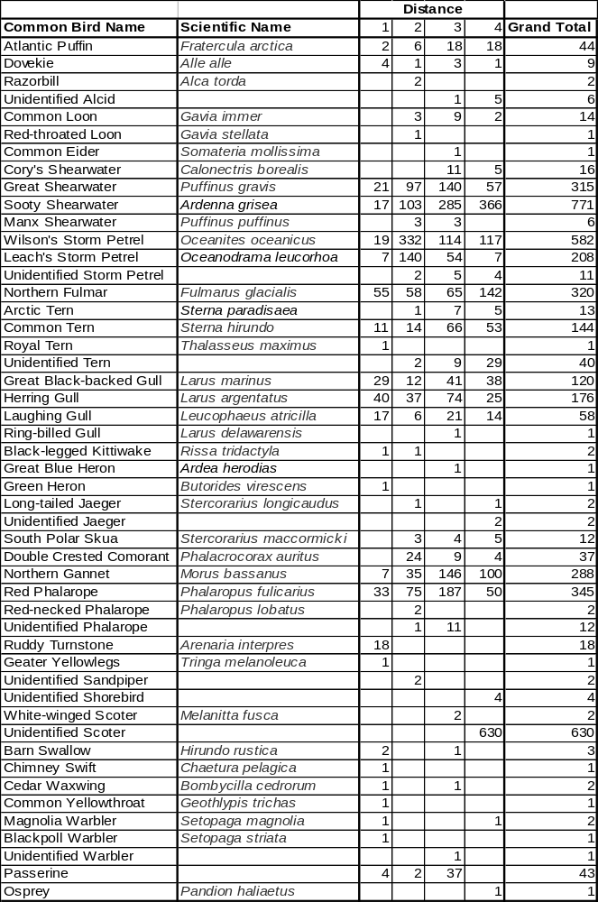
Marine Mammal, Sea Turtle, and Large Fishes Sightings

The most commonly seen marine mammal, was of course, the Common Dolphin, Delphinus delphis, accounting for approximately 66.4% of all mammal sightings, followed by Bottlenose Dolphins, Tursiops truncates, at approximately 12.8%. Of the large whales, Humpback Whales, Megaptera novaengliae, made up almost half of identified whales, followed by Unidentified Whales, making up about a quarter of all whales seen. There were a fair number of Sei Whales seen on this survey compared to past EcoMon Cruises, with a total of eight being seen in the Wilkinson Basin area of the Gulf of Maine.

There were only two confirmed Loggerhead sea turtle, Caretta caretta, sighted in the warmer waters off the Mid-Atlantic. Basking Sharks, Cetorhinus maximus, were mostly seen in Mid-Atlantic waters as well. It should be noted that a large concentration of Basking Sharks continued to be sighted after the end of the survey day on May 26th, 2019, with over forty more Basking Sharks sighted until around 20:00 as light conditions limited the ability to detect more Basking Sharks.

Table 2. Other Sighted Marine Megafauna

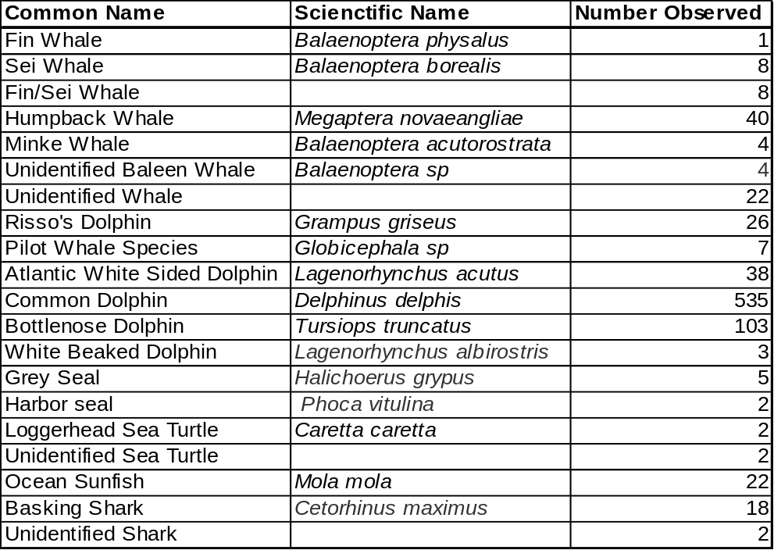

Figure 1. Transect Lines Visually Surveyed on the 2019 Spring EcoMon (HB1902)
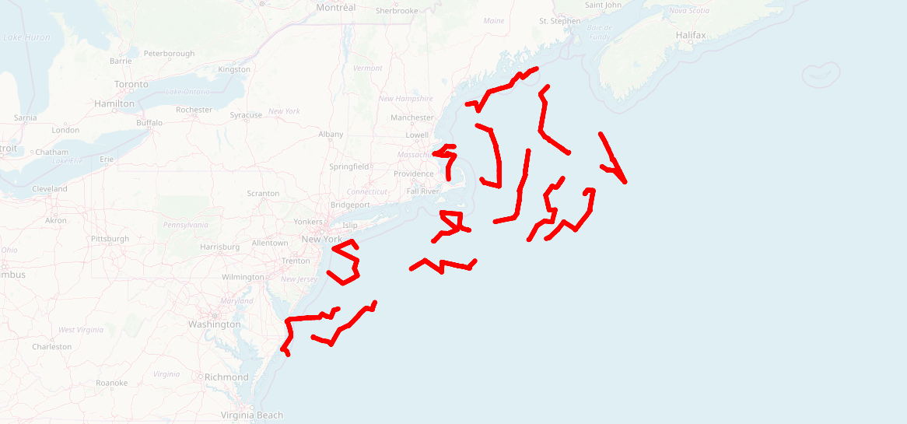

Literature Cited

Anonymous. 2011 Seabird Survey Instruction Protocol. Seabird distribution and abundance, Summer
2011. NOAA RV Henry B. Bigelow. Northeast Fisheries Science Center.

Ballance, Lisa T. 2011. Seabird Survey Instruction Manual, PICEAS 2011. Ecosystems Studies
Program Southwest Fisheries Science Center, La Jolla, California.

Heinemann, D. 1981. A range finder for pelagic bird censusing. Journal of Wildlife Management 45:
489-493.

Tasker, M.L., Hope Jones, P., Dixon, T. and Blake, B.F. 1984. Counting seabirds at sea from ships; a
review of methods employed and a suggestion for a standardized approach. Auk 101: 567 – 577.

